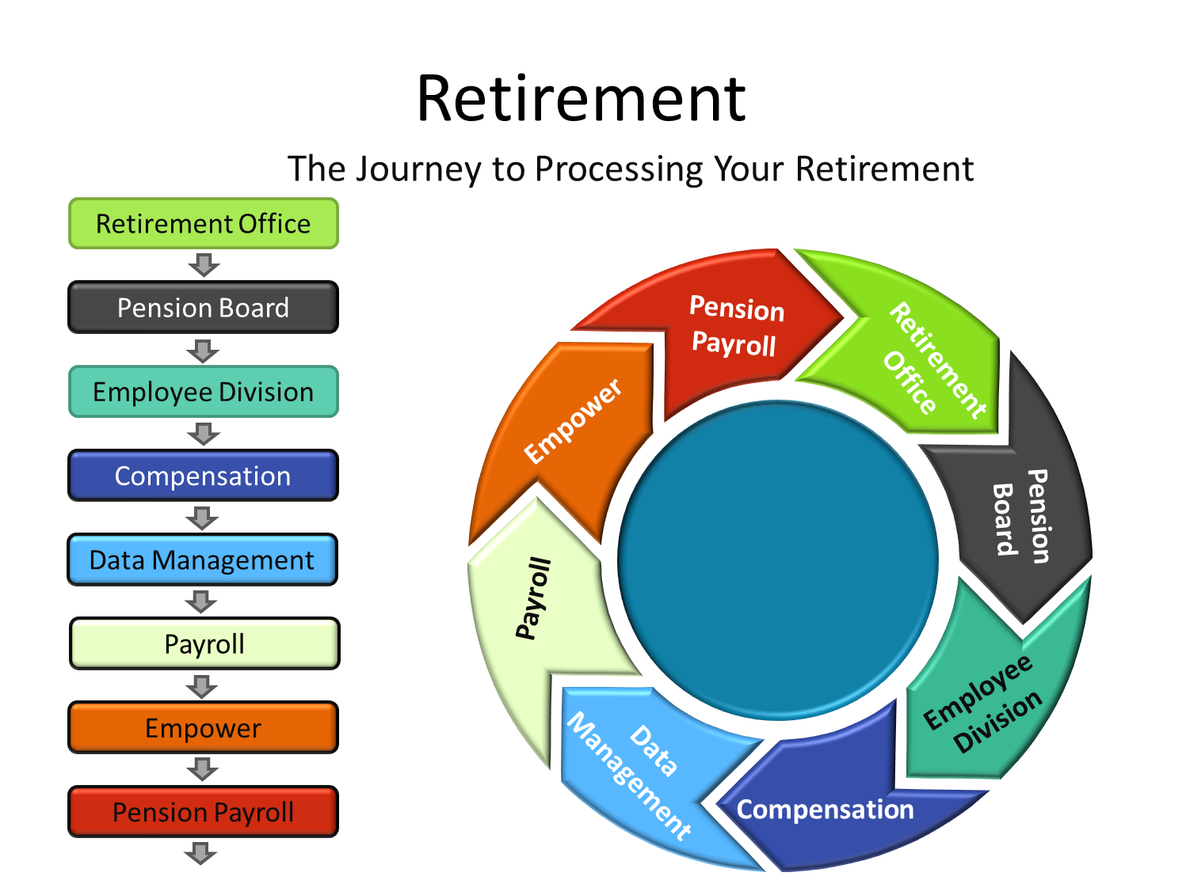
Retirement Office
- Steps in the retirement process is handled by various departments with the City of Memphis.
- The first step is to inform your supervisor in writing of your intent to retire.
- You will begin the retirement process by requesting an application from the Retirement Office. You may contact them at 901-636-6800 or email retirementquestions@memphistn.gov
- Retirement will email a link to complete your application and provide other resources to assist you with the retirement process.
- Complete the required paperwork and send to the Retirement Office. The Retirement staff is available to meet with you for an individual consultation.
- You will complete the required paperwork and send to the Retirement Office
- Retirement will process your retirement paperwork and place your name on the Pension Administration Board Agenda for a vote to approve your retirement.

Pension Board
- The Pension Administration Board Meeting is held on the 4th Thursday of each month. Sometimes the meeting must be rescheduled if we do not have at least four pension board members in attendance.
- Retirement sends your information to the Pension Administration Board for review before the meeting.
- If approved by Pension Administration Board, your division, the Payroll Office, Benefits & Pension Payroll Office will be notified of the decision.
- You will be notified if the Pension Administration Board does not vote to approve your pension disability retirement.
- If the Pension Administration Board requires additional information before they vote on your disability retirement, the Retirement Office will research information the request and place your disability retirement back on the agenda for the next meeting after the information is supplied.
Your Division
- Your division will be notified of the decision.
- City issued equipment will be collected by your division.
- Your separation from the City of Memphis will be entered into Oracle and your final pay will be processed, if applicable.
Compensation
- Compensation will review and make sure the information submitted from the division is accurate and then approve the transaction.
Data Management
- Data Management will terminate you in Oracle Fusion and EBS after the final pay is processed.
Active Payroll
- Active Payroll processes the final pay.
Empower
You complete one or all the following forms:
- 457(b)/Roth Refund Form – Withdraw your funds from your 457b account or your retirement contributions if you do not meet the normal retirement eligibility requirements.
- 457(b) & 401(a) Transfer or Rollover Form – Rollover your 457(b) Plan to City of Memphis Hybrid Pension Plan pensionable earnings to increase your annuity or transfer 401(a) to City of Memphis Pension Plan, if applicable.
- You are unable to withdraw your funds from your 457(b) fund immediately. You must be separated from City by your division and payroll must process your final pay before you can be terminated from Oracle Fusion & EBS.
Pension Payroll
- After you are terminated from Oracle Fusion and EBS, Pension Payroll will change your status from active to retired and process your retirement.
- You will receive your first pension payroll check in approximately 45 days from when you were approved by the Pension Board of Administration.
Congratulations!
- You have completed the retirement process. Enjoy your retirement.

